3/18/2020

**Skin Cancer Detection**

(Melanoma)

**Name of Student:** N. I. Md. Ashafuddula

**Roll:** **18204016**

**Program: M. Sc. Engineering in CSE Program**

**Course:** CSE-6102

**Course Title:** Advanced Image Processing

**INTRODUCTION:**

Melanoma is one kind of skin cancer and it is the most dangerous one because of the increasing percentage rate of death by melanoma skin cancer. Melanoma comes from melanocyte cells, melanin-producing cells which generally result in black or brown color. Melanomas are mostly caused by exposer to UV rays that damage the DNA of skin cells. In the US alone, more than 1M American will be diagnosed in 2007 with non-melanoma skin cancer, and 59,940 will be diagnosed with melanoma according to the American Cancer Society (ACS) [3]. Fortunately, Skin cancers are rare in children. Skin Cancer Detection System is the system to identify and recognize skin cancer symptoms and diagnose melanoma in early stages.

**IMAGE ACQUISITION:**

1. *Dermoscopy*

Dermoscopy, also known as Dermatoscopy or Epiluminescence Light Microscopy (ELM). It is a kind of imaging technique used to exanimate lesions with a dermatoscope. The process is done by placing an oil immersion between the skin and the optics. The lens of a microscope is placed directly, illuminating sub-surface structures. The lighting can magnify the skin that improves on reveal most of the pigmented structure, different color shades that are not visible to the naked eye and allows direct viewing and analysis of the epidermis. The image obtained from such a dermatoscope is called Dermoscopic Image [9].

The photos of the lesions were taken with a Nikon D3 or Nikon D1x body and a Nikkor 2.8/105 mm micro-lens [4]. In most cases (95%) the distance between the lens and the lesion is approximately 33 cm [4]. The lighting conditions were set using two Multiblitz Variolite 600 flash units with a color temperature equal to 5200 Kelvin. This dataset contains only superficial spreading melanoma and naevi, thus avoiding seborrheic warts, spitz naevi, and acro lentiginous/nodular melanomas. The images of pigmented skin lesions originate only from patients of Caucasian origin, who constitute the vast majority of the population in the Netherlands. For each picture, the available diagnosis has been verified by the medical correspondence of the Department of Dermatology. In order to further ensure the soundness of the data, the following selecting criteria have been employed [4]:

1. Every picture must originate from a different patient (apart from cases where a disease looks clearly different at different parts of the body, which can be included in the dataset).   
2. Each picture must be sharp and properly exposed, so it can be appropriately annotated.   
3. Each picture must be representative of the group it belongs to. Rare clinical variants, already treated and/or secondarily infected skin diseases are not included in the dataset.

From each image a region of interest is manually selected, that contains both healthy skin and (part of) a lesion, but without any distracting elements (clothes, background, jewelry, etc). The scale and size of the selected regions differ per image and are dependent on the size of the original image, which in turn depends on the size of the lesion and the location of the lesion on the body. Hair is considered a distracting element as well and has been manually removed using the Dullrazor software (Lee, Ng, Gallagher, Coldman, & McLean, 1997) [4].

**THEORY AND RELATED WORK:**

Many researchers have been working on the Computer vision approach for skin cancer detection. For segmentation of skin lesion in the input image, existing systems either use manual, semi-automatic or fully automatic border detection methods. The features to perform skin lesion segmentation used in various papers are:

Shape, color, texture, and luminance. Many border detection methods are reported in the literature [5,6] Some of the methods include histogram thresholding [7], global thresholding on optimized color channels followed by morphological operations [8], Hybrid thresholding.

The feature description of melanoma skin-cancer are[2]:

1. Melanoma comes from melanocyte cells, melanin-producing cells that are usually present in the skin. Because most melanoma cells still produce melanin, melanoma is often brown or black. Fig: a shows the form of melanoma skin cancer.

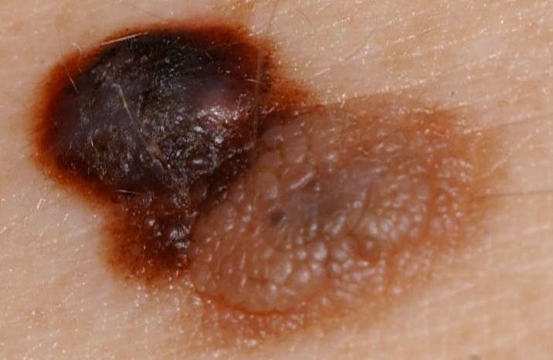 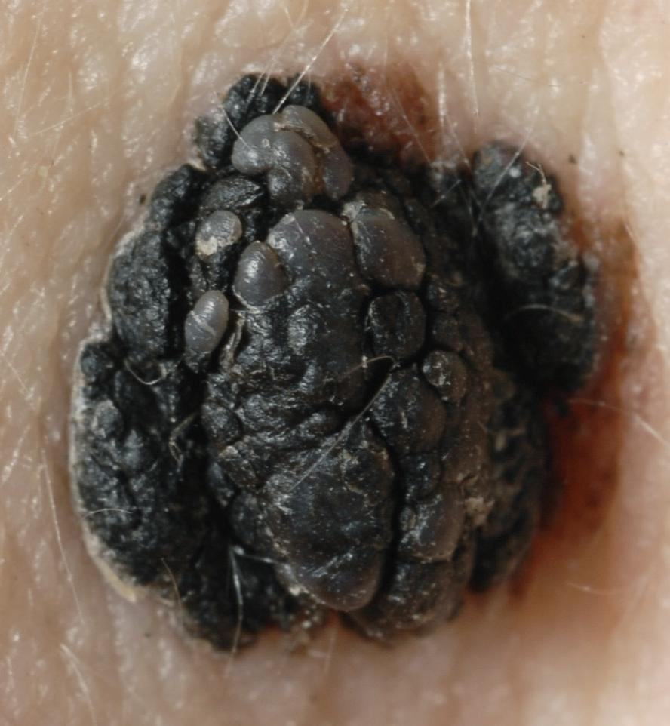 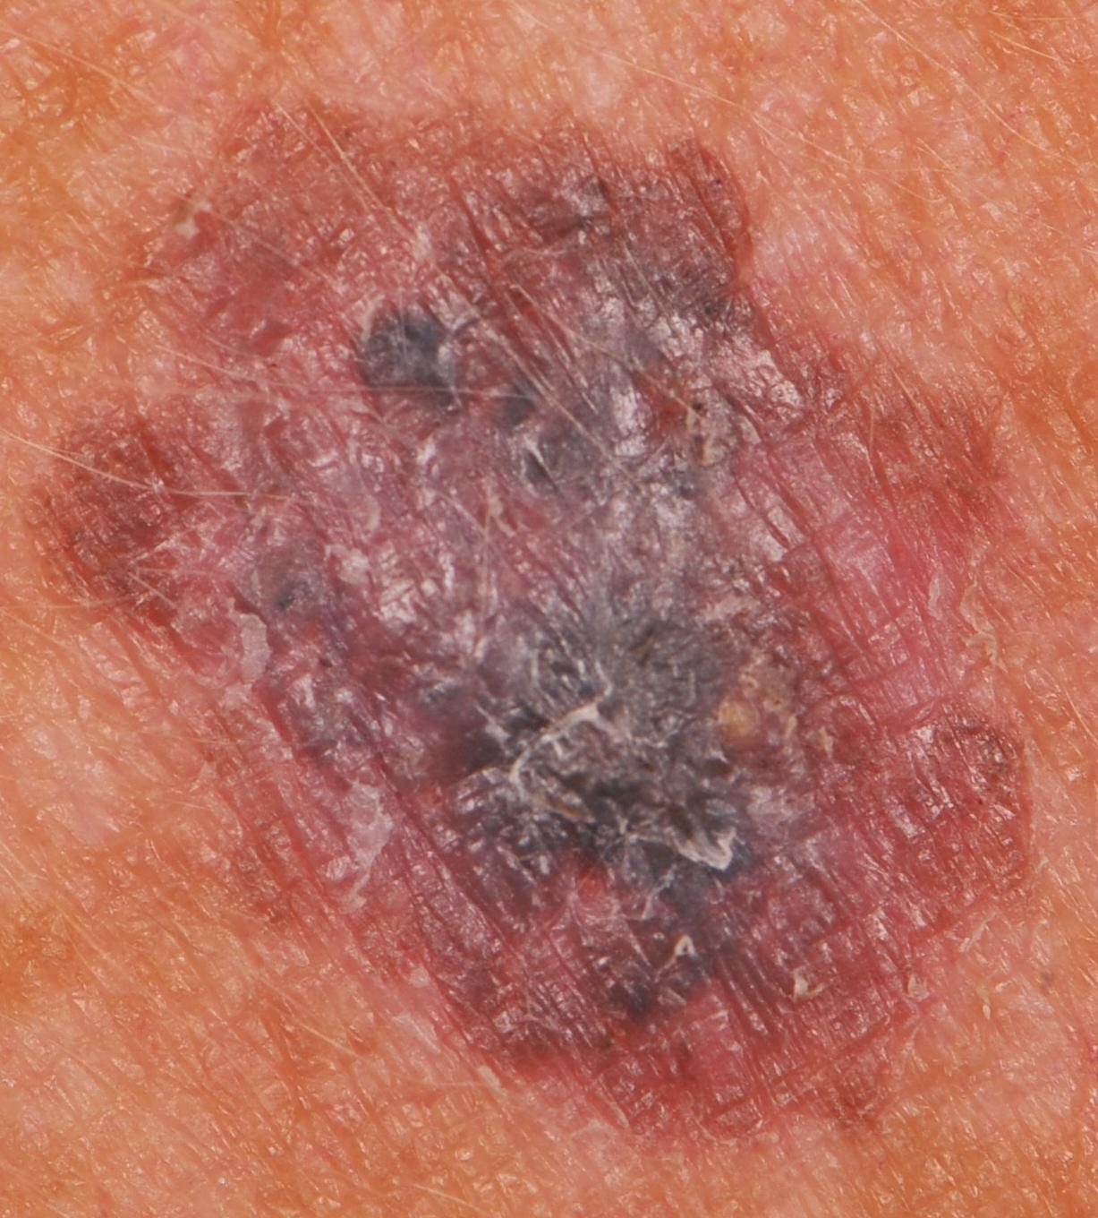

**Fig (a): Dermoscopy Images of Melanoma Cancer.**

1. Melanoma can appear on normal skin, or can appear as a mole or other area of the skin that undergoes changes. Few moles that arise at birth can turn into melanoma.

Melanoma can uccur in different body area such as, eyes, ears, gingival of upper jaw, tongue and lips.

1. Melanoma cancer is often characterized by the appearance of new moles or when there is a change in shape from an old mole.

When melanomas occur, they usually arise from pigmented nevi (moles) that are large (more than 6mm) asymmetric, with irregular borders and coloration. Bleeding, itching and a mass under the skin are other signs of cancerous change. If a child has had radiation treatment for cancer, nevi in the radiated area are at increased risk of becoming cancerous.

Characteristices of melanoma cancer:

1. Melanoma mole usually has more than one color
2. Irregular in shape
3. Its diameter is greater than 6 mm
4. It feels itchy and can bleed

To distinguish normal moles from melanoma, it can be examined for it’s from with the ABCDE list, as follows:

1. Asymmetrical: melanoma has an irregular shape and cannot be divided in hulf.
2. Border: Melanoma has an uneven & rough edge, unlike normal moles.
3. Color: melanoma is usually a mixture of two or three colors.
4. Diameter: melanoma is usually larger than 6 mm in diameter & different from normal moles
5. Enlargement or evolution: moles that can change shape and size after a while will usually become melanoma.

In this study, we have applied an Automatic Thresholding technique with series of different steps of image processing to identify features of melanoma images accurately then push the images in our CNN (Convolutional Neural Network) Model.

**METHODOLOGY:**

The proposed system, as shown in the block diagram of Fig. 11, consists of a preprocessing step. The goal of this step is to reduce artifacts that could mislead the convolutional neural network. Preprocessed images are fed into the second stage which is a CNN. Convolutional Neural Network (CNN/ ConvoNet) is one of the deep learning algorithms that is known for the best for solving object recognition & most commonly applied to analyzing visual imagery.   
The CNN model consists of 6 Convolutional layers with activation function ReLu and 7 fully connected layers. We used different kernel for Convolutional layer and maxpooling layer.  
Output layer predict Melanoma or Naevus using Softmax function, which predicts the probability of Melanoma or Naevus.

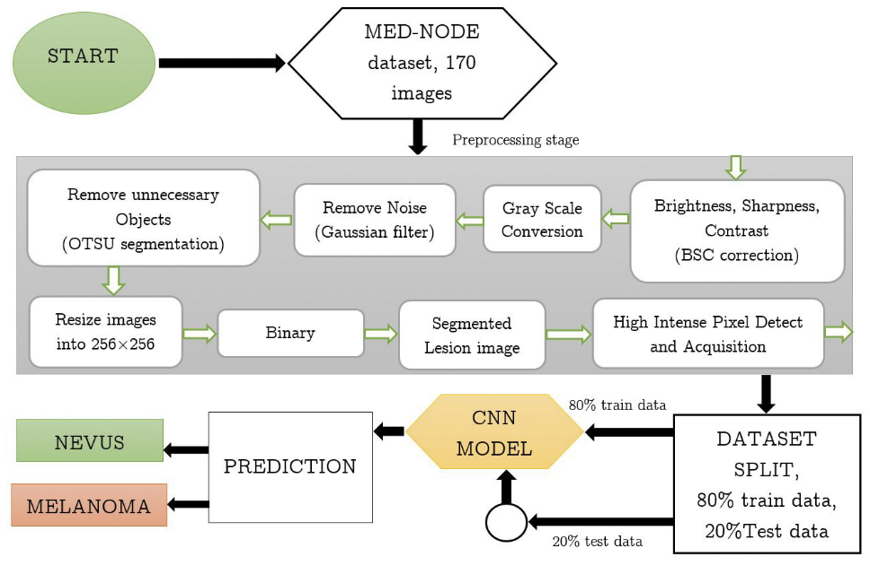

Fig, (b): PROPOSED METHOD

**DATASET:**

Our dataset1 consists of 70 melanoma and 100 naevus images from the digital image archive of the Department of Dermatology of the University Medical Center Groningen (UMCG) used for the development and testing of the MED-NODE system for skin cancer detection from macroscopic images.

1. <http://www.cs.rug.nl/~imaging/databases/melanoma_naevi/> (Last changed: 26-07-2015.)

**MODEL DETAILS:**

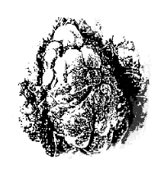

Fig, 3: Convert to GreyScale

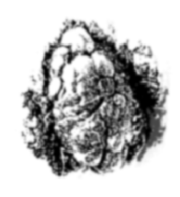

Fig, 4: Gaussian Filter

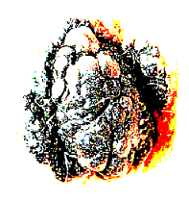

Fig, 2: Correction BCS

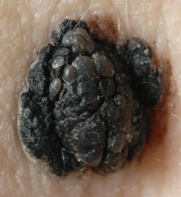

Fig, 1: Input Image

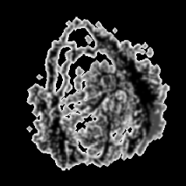

Fig, 9: Create Lession Mask

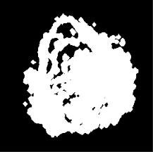

Fig, 8: Binary Openning

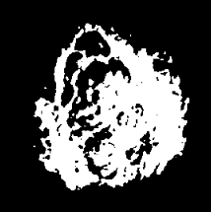

Fig, 7: Resize Image

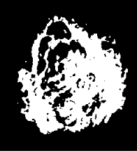

Fig, 5: OTSU segmentation

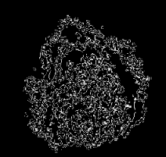

Fig, 10: High Intese Pixel Detection (Taken Pixel Value>190)

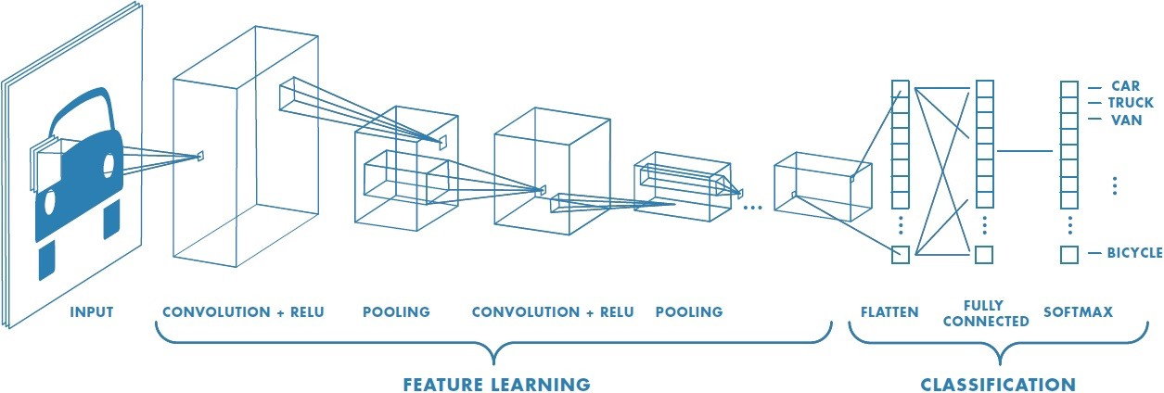

Fig 11: CNN/ ConvoNet work follow.

**RESULT:**

In this section, the proposed method is evaluated on a publically available dataset of skin lesion images [4]. This dataset consists of 170 non-dermoscopic images (70 melanoma, 100 nevus) from the digital image archive of the Department of Dermatology of the University Medical Center Groningen (UMCG). The proposed system is implemented on Google Colab.

The training set contains 135 shuffle images (54 Melanoma, 81 Nevus) and 35 test images (16 Melanoma, 19 nevus). After 40 epoch we got 100% training accuracy.

After testing our system using the test dataset we got 92.58% accuracy. Where the proposed methodology using KNN classifier [4] they achieved 81% accuracy.

**Table, 1: Experiment Result Analysis**

|  |  |
| --- | --- |
| *METHOD* | *ACCURACY* |
| **PROPOSED MEHODOLOGY** | **92.58%** |
| ARCH of CNN [10] | 81.0% |
| MED-NODE PROPOSED SYSTEM using KNN [4] | 81.0% |

**CONCLUSION:**

In this paper, a computational complex method based on deep learning was implemented that used clinical images. This system was capable of detecting melanoma cases from nevus ones. We were able to increase the accuracy of the system by sending images through illumination correction that increased the discrimination capability of the system. For training, we used an available small dataset. Our proposed method left the process of feature extraction to CNN while traditional learning approaches try to extract features from data. Our experimental results showed better accuracy, as compared to other detection algorithms.

**REFERENCES:**

1. Han, Seung Seog, et al. "Classification of the clinical images for benign and malignant cutaneous tumors using a deep learning algorithm." *Journal of Investigative Dermatology* 138.7 (2018): 1529-1538

2. Refianti, Rina, Achmad Benny Mutiara, and R. Poetri Priyandini. "Classification of Melanoma Skin Cancer using Convolutional Neural Network." *Int. J. of Advanced Computer Science and Applications* 10.3 (2019).

3. Jaiswar, Sanjay, Mehran Kadri, and Vaishali Gatty. "Skin Cancer Detection Using Digital Image Processing." *International Journal of Scientific Engineering and Research* 3.6 (2015): 138-140.

4. Giotis, Ioannis, et al. "MED-NODE: a computer-assisted melanoma diagnosis system using non-dermoscopic images." Expert systems with applications 42.19 (2015): 6578-6585.

5. R. Garnavi, Computer-aided diagnosis of melanoma, Ph.D. dissertation, Universityof Melbourne, Australia, 2011

6. M.E. Celebi, H. Iyatomi, G. Schaefer, and W. V. Stoecker, Lesion border detection in dermoscopy images Computerised Medical Imaging and Graphics, vol. 33, no. 2, pp. 148–153, 2009

7. H. Iyatomi, H. Oka, M. Saito, A. Miyake, M. Kimoto, J. Yamagami, S. Kobayashi, A. Tanikawa, M. Hagiwara, K. Ogawa, G. Argenziano, H.

P. Soyer, and M. Tanaka, Quantitative assessment of tumour extraction fromdermoscopy images and evaluation of computer-based extraction methodsfor an automatic melanoma diagnostic system Melanoma Research, vol. 16, no. 2, pp. 183–190, 2006

8. R. Garnavi, M. Aldeen, M. E. Celebi, A. Bhuiyan, C. Dolianitis, and G. Varigos, Automatic segmentation of dermoscopy images using histogram thresholding on optimal color channelsInternational Journal of Medicine and Medical Sciences,vol. 1, no. 2, pp. 126–134, 2010

9. Jaleel, Dr J. Abdul, Sibi Salim, and R. B. Aswin. "Artificial neural network based detection of skin cancer." International Journal of Advanced Research in Electrical, Electronics and Instrumentation Engineering 1.3 (2012).

10. Nasr-Esfahani, Ebrahim, et al. "Melanoma detection by analysis of clinical images using convolutional neural network." 2016 38th Annual International Conference of the IEEE Engineering in Medicine and Biology Society (EMBC). IEEE, 2016.